NEW HEIGHTS SCHOOL

GRADES K-1

STUDENT SUPPLIES (please label with student’s name)

4 large glue sticks
1 box of crayons - 24 count
2 box of markers – 10 count
2 box of sharpened colored pencils
12 #2 sharpened pencils
1 plastic pencil box
1 set of watercolors paints
1 scissors
2 3-ring binder with front sleeve (1-inch-thick)
2 spiral-bound wide-ruled notebooks
2 paper pocket folders
1 packet of clear plastic inserts
8 black only dry erase markers (thick)
1 sketchbook, blank, unlined paper
1 set of personal headphones
(not earbuds)
1 backpack
Gym shoes (with non-marking soles)

CLASSROOM SUPPLIES
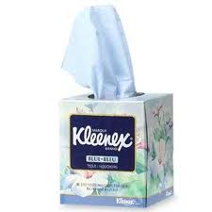
2 boxes of facial tissue
2 rolls of paper towels
1 container of disinfectant wipes
1 box gallon-size plastic bags
1 box of sandwich bags

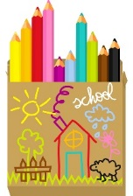
SCHOOL SUPPLY LIST

GRADES 2-3

STUDENT SUPPLIES (please label with student’s name)

2-heavy-duty 3 ring binder (1 inch thick with durable view)
3 spiral college-ruled notebooks
3 paper pocket folders
1 box of colored pencils
1 box of thin markers
1 box of thick markers
1 set of watercolor paints
2 plastic pencil boxes
6 thin black only Expo Dry Erase Markers
24 #2 pencils – sharpened
1 box of Crayola crayons (24 count)
1 pair of scissors
2 large glue sticks
1 sketchbook, blank, unlined paper
1 set of personal headphones (not earbuds)
1 backpack
Gym shoes (with non-marking soles)

CLASSROOM SUPPLIES
1 box of facial tissue
1 container of disinfecting wipes

Optional: white card stock

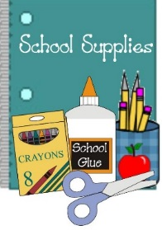
SCHOOL YEAR 2022-2023

GRADE 4-5

STUDENT SUPPLIES (please label with student’s name)

2 heavy duty 3 ring binder 1 inch thick (with clear front sleeve)
4 spiral notebooks (red blue yellow green)
4 2 pocket plastic folders (red blue yellow green)
1 pocket folder design of your choice
1 wide ruled composition notebook
1 scissors (not child-sized adult sized)
2 large erasers
24 plain #2 pencils
4 black dry erase markers (thin)
1 box of markers
1 box 12 colored pencils
1 box of Crayola crayons 24
2 large glue sticks
2 highlighters
1 Plastic pencil box
1 sketchbook with blank unlined white pages
1 pack of clear pocket inserts for binder
1 set of personal headphones (no earbuds)
1 backpack
1 pair of gym shoes (with non-marking soles)
CLASSROOM SUPPLIES
One container of disinfectant wipes
One box of facial tissue
Optional:
White card stock

